## Annual Flux vs annual met variables

## C:\Users\Tin WS\Documents\Courses UBC\my research thesis\BB1_interannual\plots\corr_CH4_gC_RF_vs_GPPgC_f_RF.png C:\Users\Tin WS\Documents\Courses UBC\my research thesis\BB1_interannual\plots\corr_CH4_gC_RF_vs_max_WTD.png

## Annual flux vs seasonal met variables

## C:\Users\Tin WS\Documents\Courses UBC\my research thesis\BB1_interannual\plots\corr_an_vs_GS_CH4_gC_RF_vs_TS.5.png C:\Users\Tin WS\Documents\Courses UBC\my research thesis\BB1_interannual\plots\corr_an_vs_NGS_CH4_gC_RF_vs_max_wtd.pngC:\Users\Tin WS\Documents\Courses UBC\my research thesis\BB1_interannual\plots\corr_an_vs_NGS_CH4_gC_RF_vs_max_Ta.pngC:\Users\Tin WS\Documents\Courses UBC\my research thesis\BB1_interannual\plots\corr_an_vs_GS_GPPgC_f_RF_vs_TS.5.pngC:\Users\Tin WS\Documents\Courses UBC\my research thesis\BB1_interannual\plots\corr_an_vs_NGS_GPPgC_f_RF_vs_min_wtd.pngC:\Users\Tin WS\Documents\Courses UBC\my research thesis\BB1_interannual\plots\corr_an_vs_GS_GPPgC_f_RF_vs_min_TS.5.png C:\Users\Tin WS\Documents\Courses UBC\my research thesis\BB1_interannual\plots\corr_an_vs_GS_RecogC_vs_TS.5.png C:\Users\Tin WS\Documents\Courses UBC\my research thesis\BB1_interannual\plots\corr_an_vs_NGS_RecogC_vs_min_wtd.pngC:\Users\Tin WS\Documents\Courses UBC\my research thesis\BB1_interannual\plots\corr_an_vs_NGS_NEEgC_f_RF_vs_wtd.png

## Seasonal flux vs seasonal met variables

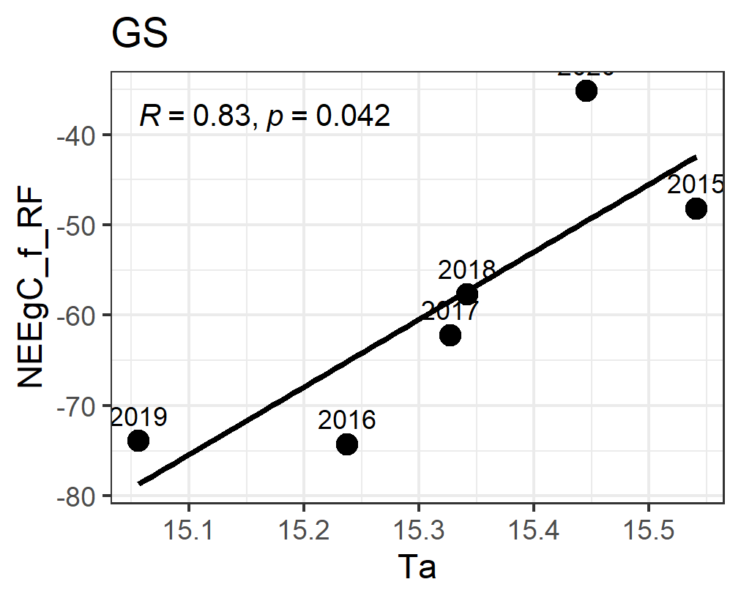 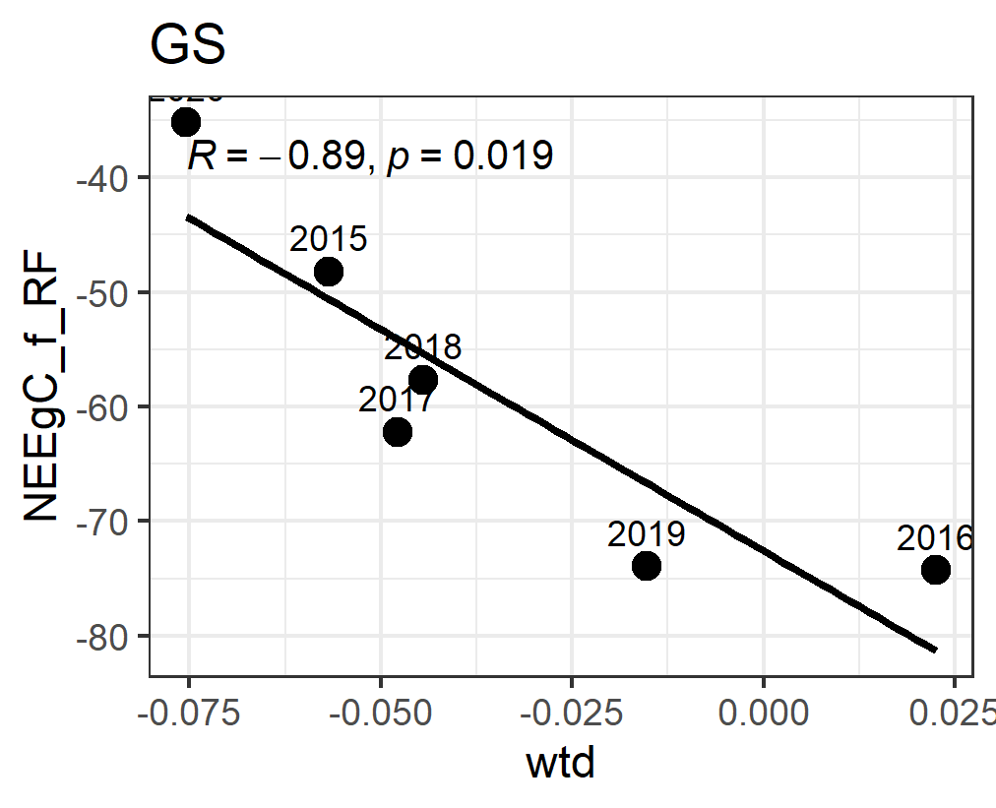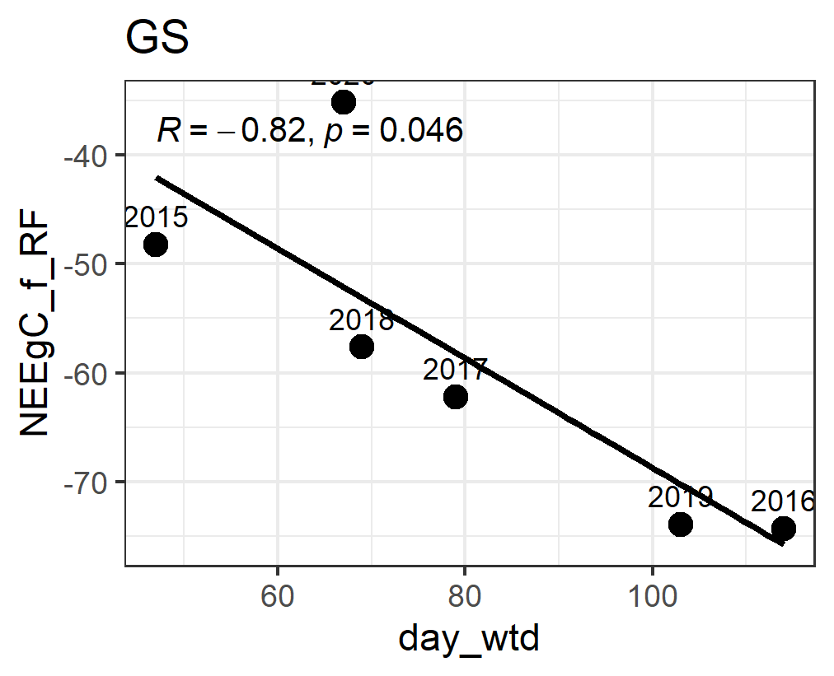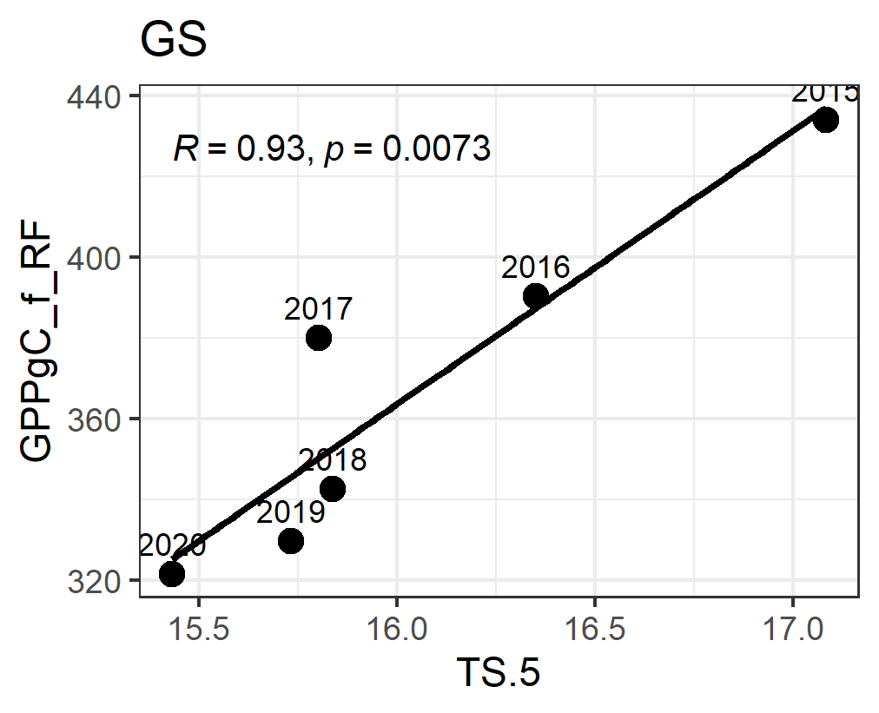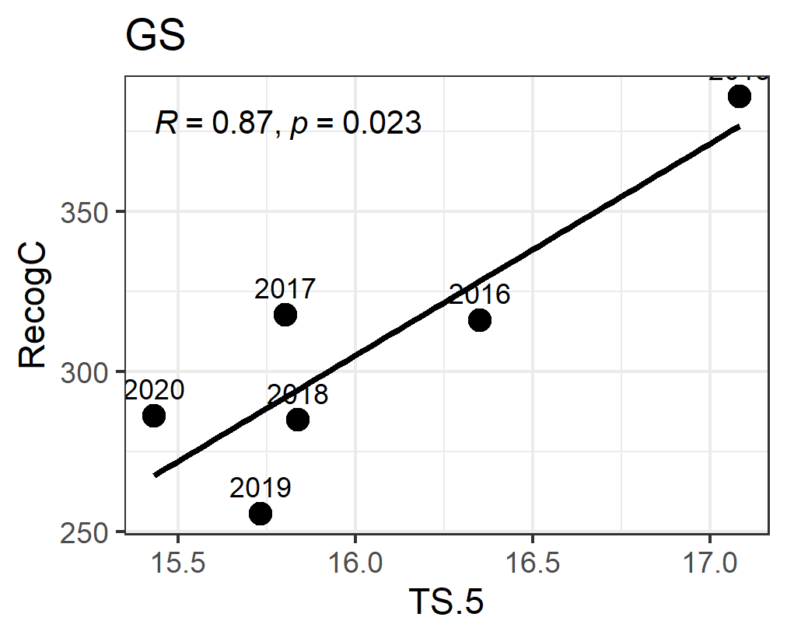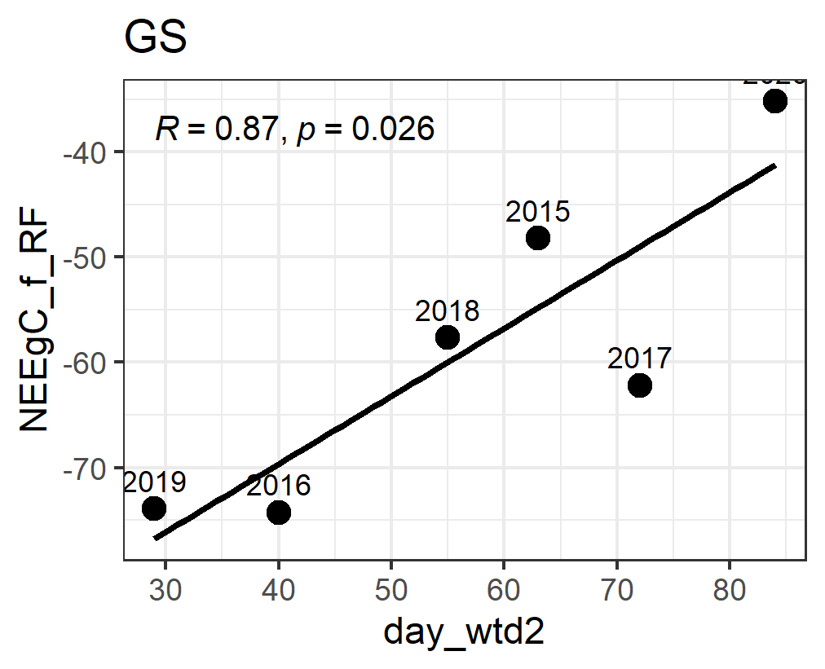

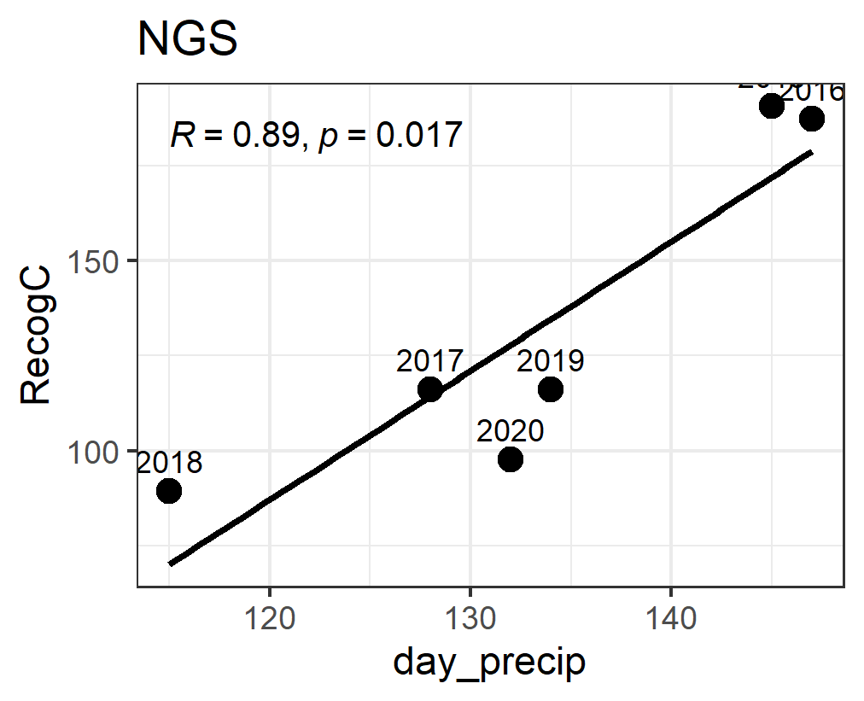 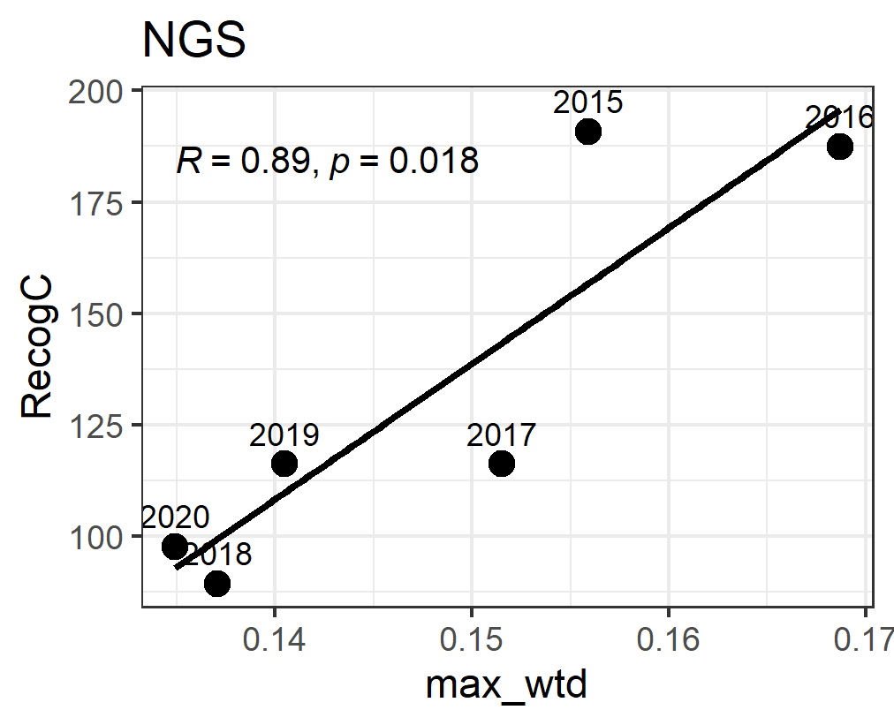

## Annual Flux vs PI